**BOOTLEG GAP GOLF**

**FOUNDER MEMBERSHIPS**

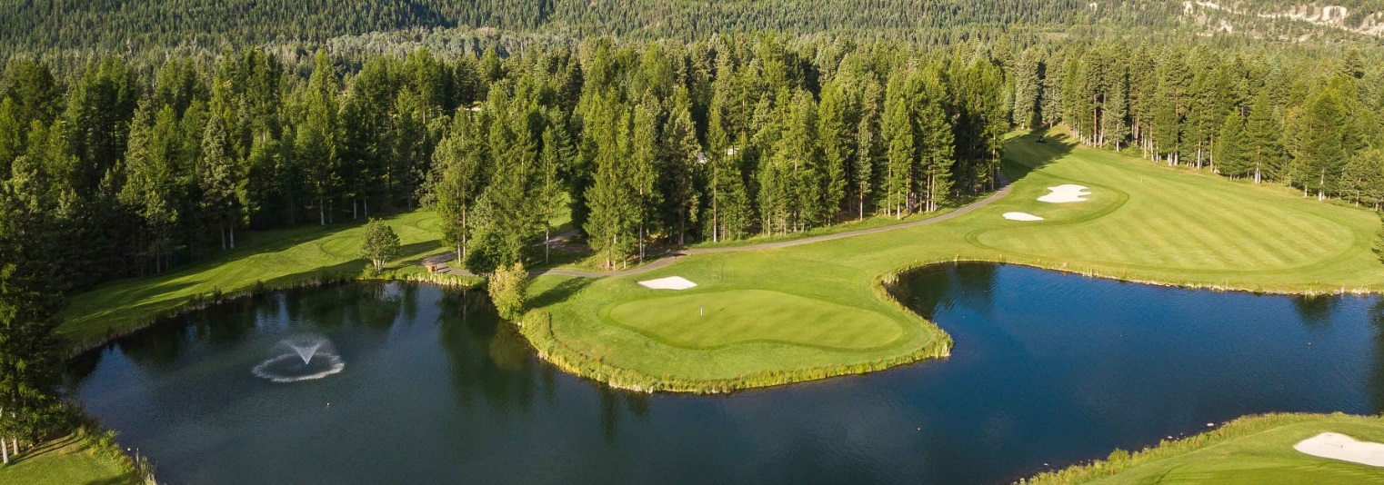

The Simkins Family is in the final stages of purchasing Bootleg Gap Golf from the City of Kimberley. Beginning in February 2021, we will take over all operations of the golf course. The Simkins Family is pleased to announce a new Bootleg Gap Golf Founder Membership. This incredible, exclusive offer will be the only opportunity to enjoy unlimited annual golf at Bootleg Gap. Take advantage of a fixed golf rate over the next 20 or 40 years. With the flexibility **to transfer or sell** your membership at any time, you can pass on the gift of golf!

We are confident that our family’s combined 60 years in the golf industry will bring unique value and vision to the continued success of Bootleg Gap Golf. We will continue to offer a locally owned and operated golf course which will appeal to both visitors & locals; an affordable, well maintained course which offers a welcoming atmosphere. Our goal is to have Bootleg Gap Golf continue to be an entity which Kimberley is proud of.

This LIMITED TIME OFFER is the only planned Annual Membership that will be offered by Bootleg Gap!

**FOUNDER MEMBERSHIP – 40 YEAR** **FOUNDER MEMBERSHIP – 20 YEAR**

- Annually, the Founder member may assign a spouse to - **CART SEAT** included for member

their membership or choose to bring a guest for free. **- Driving range access** included for member

- **CART SEAT** included for member and spouse or guest - 15% discount in the Pro Shop and Clubhouse

- **Driving range access** for member and spouse or guest - One discounted guest rate per day

- 15% discount in the Pro Shop and Clubhouse - 10- day advance booking on either course

- Two discounted guest rates per day - Complimentary guest not included

- 10- day advance booking on either course - Only 12 twenty-year Memberships available

- Only 6 forty-year Memberships available **-** Sell or transfer your membership at any time

- Sell or transfer your membership at any time **- $20,000 plus GST**

**- $40,000 plus GST**

THIS IS A LIMITED TIME OFFER! For more information or to request an application package, please email Trevor Simkins, GM, Bootleg Gap Golf at [proshop@bootleggapgolf.com](mailto:proshop@bootleggapgolf.com)